**CS405 Machine Learning**

**Lab # Bayes**

**Lab (100 points)**:

Text mining (deriving information from text) is a wide field which has gained popularity with the huge text data being generated. Automation of a number of applications like sentiment analysis, document classification, topic classification, text summarization, machine translation, etc has been done using machine learning models. In this lab, you are required to write your spam filter by using naïve Bayes method. This time you should not use 3rd party libraries including scikit-learn.

**Instruction**:

Spam filtering is a beginner’s example of document classification task which involves classifying an email as spam or non-spam (a.k.a. ham) mail. Email dataset will be provided. We will walk through the following steps to build this application:

1. Preparing the text data
2. Creating word dictionary
3. Feature extraction process
4. Training the classifier
5. Checking the results on test set

**Preparing the text data:**

The data-set used here, is split into a training set and a test set containing 702 mails and 260 mails respectively, divided equally between spam and ham mails. You will easily recognize spam mails as it contains *spmsg* in its filename.

In any text mining problem, text cleaning is the first step where we remove those words from the document which may not contribute to the information we want to extract. Emails may contain a lot of undesirable characters like punctuation marks, stop words, digits, etc which may not be helpful in detecting the spam email. The emails in Ling-spam corpus have been already preprocessed in the following ways:

1. Removal of stop words – Stop words like “and”, “the”, “of”, etc are very common in all English sentences and are not very meaningful in deciding spam or legitimate status, so these words have been removed from the emails.
2. Lemmatization – It is the process of grouping together the different inflected forms of a word so they can be analyzed as a single item. For example, “include”, “includes,” and “included” would all be represented as “include”. The context of the sentence is also preserved in lemmatization as opposed to stemming (another buzz word in text mining which does not consider meaning of the sentence)

We still need to remove the non-words like punctuation marks or special characters from the mail documents. There are several ways to do it. Here, we will remove such words after creating a dictionary, which is a very convenient method to do so since when you have a dictionary, you need to remove every such word only once.

**Creating word dictionary:**

We will only perform text analytics on the content to detect the spam mails. As a first step, we need to create a dictionary of words and their frequency. For this task, training set of 700 mails is utilized. This python function creates the dictionary for you.

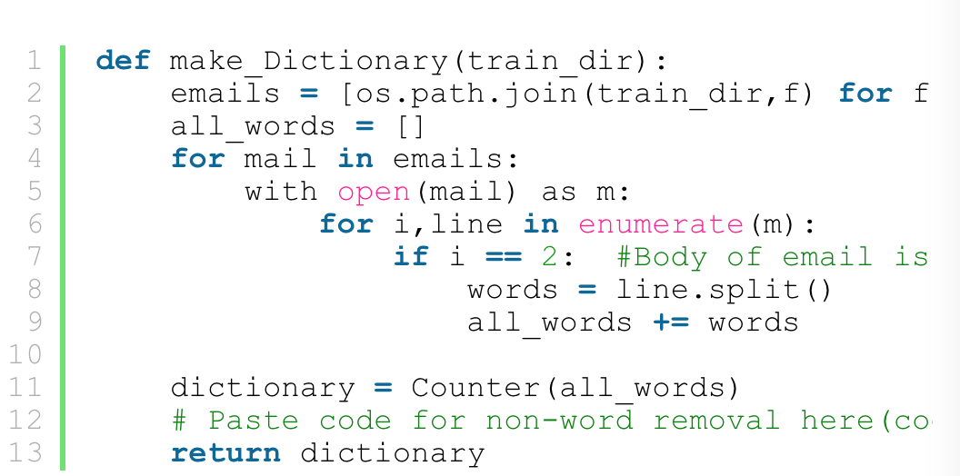

Once the dictionary is created we can add just a few lines of code written below to the above function to remove non-words about which we talked in step 1. I have also removed absurd single characters in the dictionary which are irrelevant here. Do not forget to insert the below code in the function def make_Dictionary(train_dir).

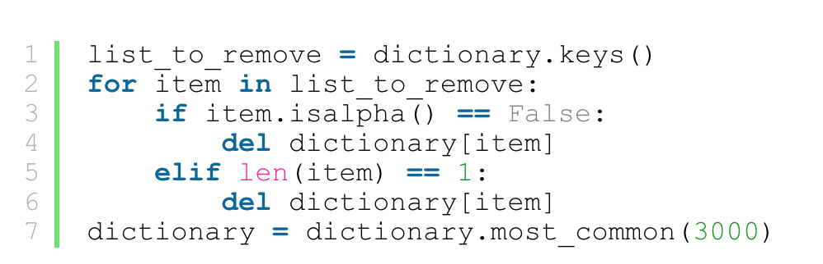

Dictionary can be seen by the command print dictionary. You may find some absurd word counts to be high but don’t worry, it’s just a dictionary and you always have the scope of improving it later. If you are following this document with provided data-set, make sure your dictionary has some of the entries given below as most frequent words. Here I have chosen 3000 most frequently used words in the dictionary.

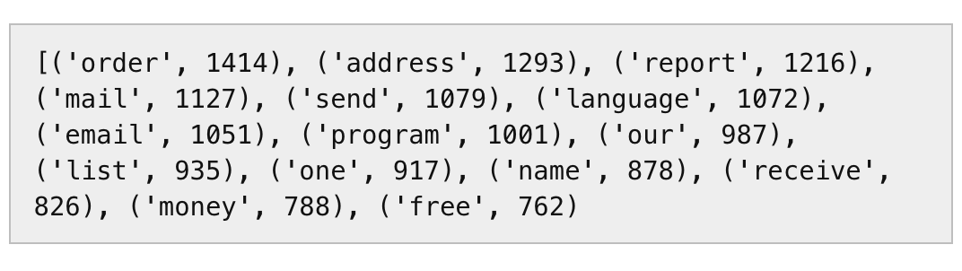

**Feature Extraction Process**

Once the dictionary is ready, we can extract word count vector (our feature here) of 3000 dimensions for each email of training set. Each **word count vector** contains the frequency of 3000 words in the training file. Of course you might have guessed by now that most of them will be zero. Let us take an example. Suppose we have 500 words in our dictionary. Each word count vector contains the frequency of 500 dictionary words in the training file. Suppose text in training file was “Get the work done, work done” then it will be encoded as [0,0,0,0,0,…….0,0,2,0,0,0,……,0,0,1,0,0,…0,0,1,0,0,……2,0,0,0,0,0]. Here, all the word counts are placed at 296th, 359th, 415th, 495th index of 500 length word count vector and the rest are zero.

The below python code will generate a feature vector matrix whose rows denote 700 files of training set and columns denote 3000 words of dictionary. The value at index ‘*ij’* will be the number of occurrences of jth word of dictionary in ith file

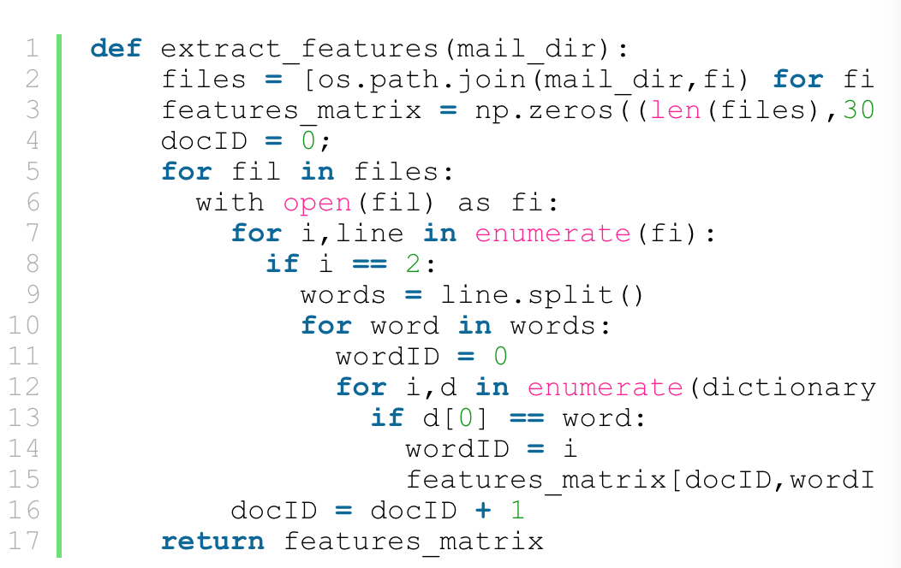

**Training the Classifiers:**

Here you should write your Naïve Bayes classifiers when fully understanding its theory.

**Checking Performance**

Test set contains 130 spam emails and 130 non-spam emails. Please compute accuracy, recall, F-1 score to evaluate the performance of your spam filter.